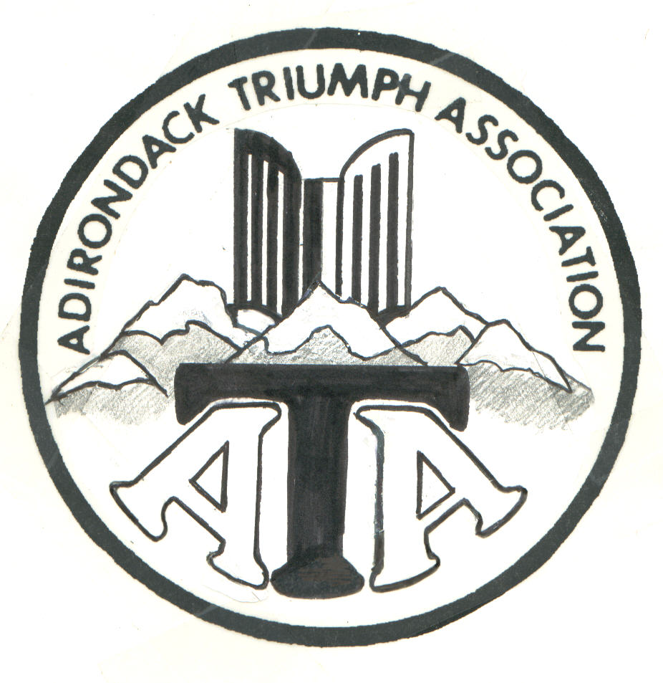 | Adirondack Triumph Association www.ata-ny.org  ALL British Cars & Motorcycles Welcome  ATA IS A MULTI- MARQUE CLUB | Erik Gebhardt, President  David Faulkner, VP for Activities  Pete Fullam, VP for Car Shows  Pat King, Secretary  Valerie Kushner, Treasurer  Erik Gebhardt, Webmaster
 | MEMBERSHIP APPLICATION or RENEWAL
Membership in the Adirondack Triumph Association is open to anyone with an interest in British cars or motorcycles. Ownership of a Triumph car or motorcycle or any other British vehicle is not required.

Check one: New Application Renewal: ATA Membership # ________
For RENEWAL: Please fill in your name, membership # if known, any changes in your information and how you would like to receive “The British Marque”

Dues are $30 per year, payable by January 31^{st.} New members or late renewals after July 31st pay $15.
Please print all information & mail with check payable to: ATA or Adirondack Triumph Assoc. to … ATA c/o Pat King 103 Bunker Hill Road Valley Falls NY 12185
If you have any questions, please e-mail patATA@nycap.rr.com
Name:
Family Members:
Address:
City: State: Zip: Home Phone: ( )
Occupation: Cell Phone: ( )
E-Mail Address (Please Print Clearly):
**A subscription to the “British Marque” Car Club News is included (circle one): MAIL or E-MAIL**
Triumph Owners Only: Vintage Triumph Register Member # _________ , if applicable.

Please list all British vehicles that you currently own * More than 6? LIST ON BACK *
Year Make and Model Year Make and Model

______

SIGNATURE: ___________________________________ DATE: _______________________

( ATA: Rec’d:__________ #:_________ Data entry:__________ Note _________+)

